83.03.12b
From Charles Fawcett
RB MSS M7, Library, Royal Botanic Gardens Melbourne.

Murwillumbah
N. S. Wales.
12 March 1883.

Many thanks, My dear Baron, for your kind letter and good wishes. At the same time I confess that, when I got rid of the "exigence" of parliamentary life, I did not think of being so soon put into harness again, although in another capacity. The exacting duties of P. M & Land Agent combined give very little time to do anything else, and I suppose it probable that I am a fixture here for the next month. I took a holiday today to write some letters &c. I made up some specimens which you should receive with this letter. The flowers of the nut tree I referred to in a former letter will have to be cut out of the tin canister in which they are packed. It seems a strange thing that this tree did not make its appearance here until brush land was cleared. It is not known on the Richmond. I have had much trouble in drying the leaves on account of the wet weather. I am not acquainted with the method of drying specimens as mentioned in your letter. When you speak of Mt Gipps I think you must refer to Mt Lindsay at the head of the Richmond. It was ascended some years ago by young Mr Pryor of the Logan in company with a friend, but I understand it is now inaccessible in consequence of the burning of the scrub in one particular part. I saw a piece of rock they brought down; it was black and heavy and had impressions of fern leaves on it & through it. Mount Warning at the head of this river is a magnificent mountain right in front of me as I write. It can only be ascended on the side where the x is — 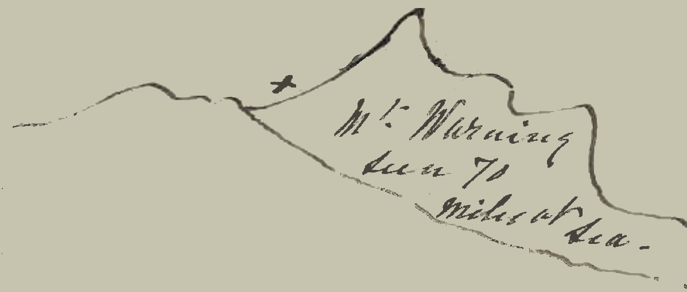
Several people have been up at different times. It is nearly 1000 feet lower than Mt Lindsay, but then it is much nearer the sea — As to getting any adventurous young man to undertake the job you mentioned it would be out of the question. There is no getting anything done, labour is so scarce, except cane cutting and those who are hired for this work are a rough, rowdy lot. I might make a trip up Mt Warning myself before I leave here. I write by this post to have the petrified wood sent to you, but any information respecting locality, &c, I shall have to defer till I go next to Lismore. Sir Henry Parkes, who was returned for Tenterfield, when rejected in Sydney, has been up there lately & has visited Casino and Lismore & the Clarence. I regret that it was not in my power to be at the former places to meet him.
I am yrs truly,
Charles H Fawcett.

Baron. F. von Mueller
&c &c &c

MS found with a specimen of Hicksbeachia pinnatifolia (MEL 109015). MS annotation by M: 'Answ 21/3/83 FvM'. Letter not found.
On C. Fawcett to M, 21 February 1883, M noted that he replied to the letter on 7 March 1883, but M's letter has not been found.
See C. Fawcett to M, 21 February 1883.
Police Magistrate.
See C. Fawcett to M, 21 February 1883.
Richmond River, NSW.
Mt Lindesay?
Fawcett includes here a small sketch outline of the coast and the river, with a small cross and the annotation: 'Mt Warning seen 70 miles at sea': 83-03-12b_image01.jpg
Parkes, the Prime Minister of NSW, lost his seat of East Sydney following the dissolution of Parliament on 16 November 1882, but subsequently won the provincial seat of Tenterfield. In the meantime, however, his government resigned on 4 January 1883.

